Programming Exercise 1:

The visualizations and findings of Tableau Public

Student Name: Jiaqi Wei

Student ID: 29144108

## Introduction

This report aims to briefly showing my finding and visualization of the data which is about coral bleaching data for 8 sites in the Great Barrier Reef. This report dived into serval parts, the first one is the answers of the questions of this exercise. The second part is the description of the Data wrangling and data exploration.

## The answer of exercise

Question 1: In which years and for which kinds of coral bleaching is the worst?

Answer: The sea fans in 2017 is the worst.

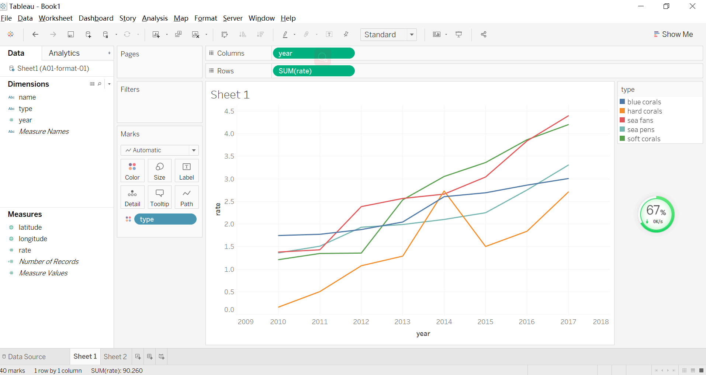

Picture 1

Question 2: How the location of the site affects bleaching on the different kinds of coral?

Answer: Picture 2 show the different rate of different corals in different location.

As for site 1, the result shows that the rate of soft corals is the highest and the rate of sea pens is lowest.

As for site 2,

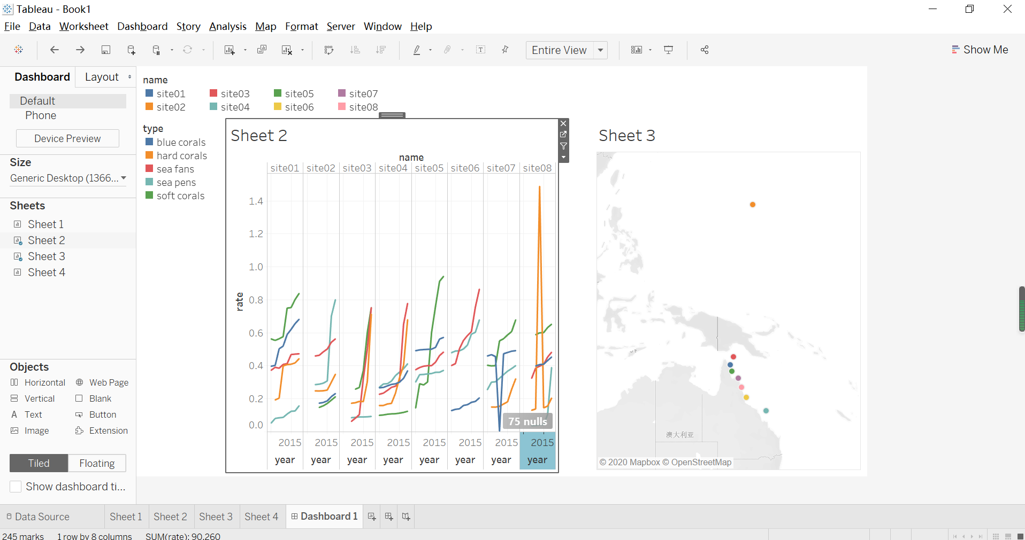

Picture 2

## The description of the Data wrangling and data exploration.

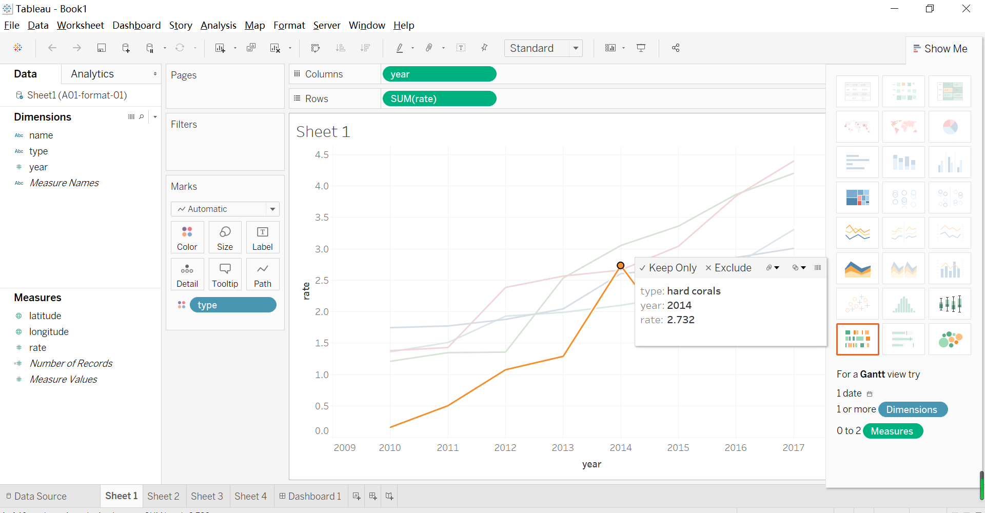

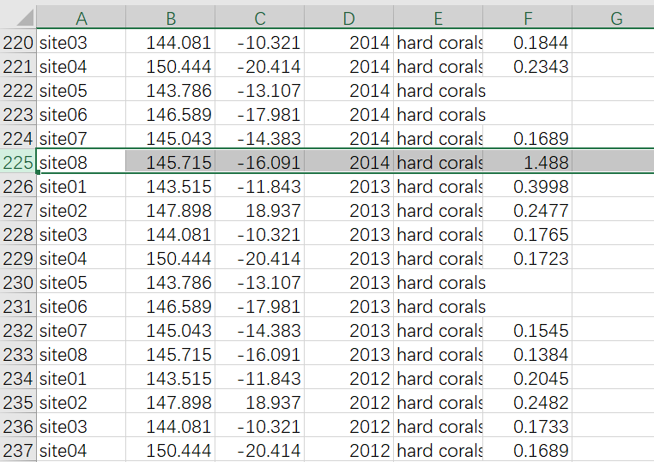

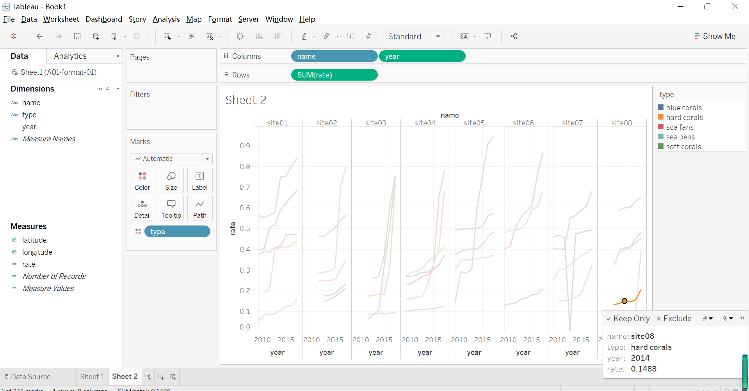

From the Picture 1, the rate of hard corals in 2014 is very strange because it increased and decreases sharply. Comparing the other data of hard corals, I think is it an error data and one of the hard corals rate in 2014 is wrong. From the Picture 2, hard corals’ rate of site in 2014 is very strange and high, because it increased sharply in 2014 and decreases to normal rate in 2015. Comparing the other data of hard corals, I think this error should be 0.1488 instead of 1.488. After changing it, the rate of hard corals increased smoothly. And the rate of hard corals in 2014 becomes correct.

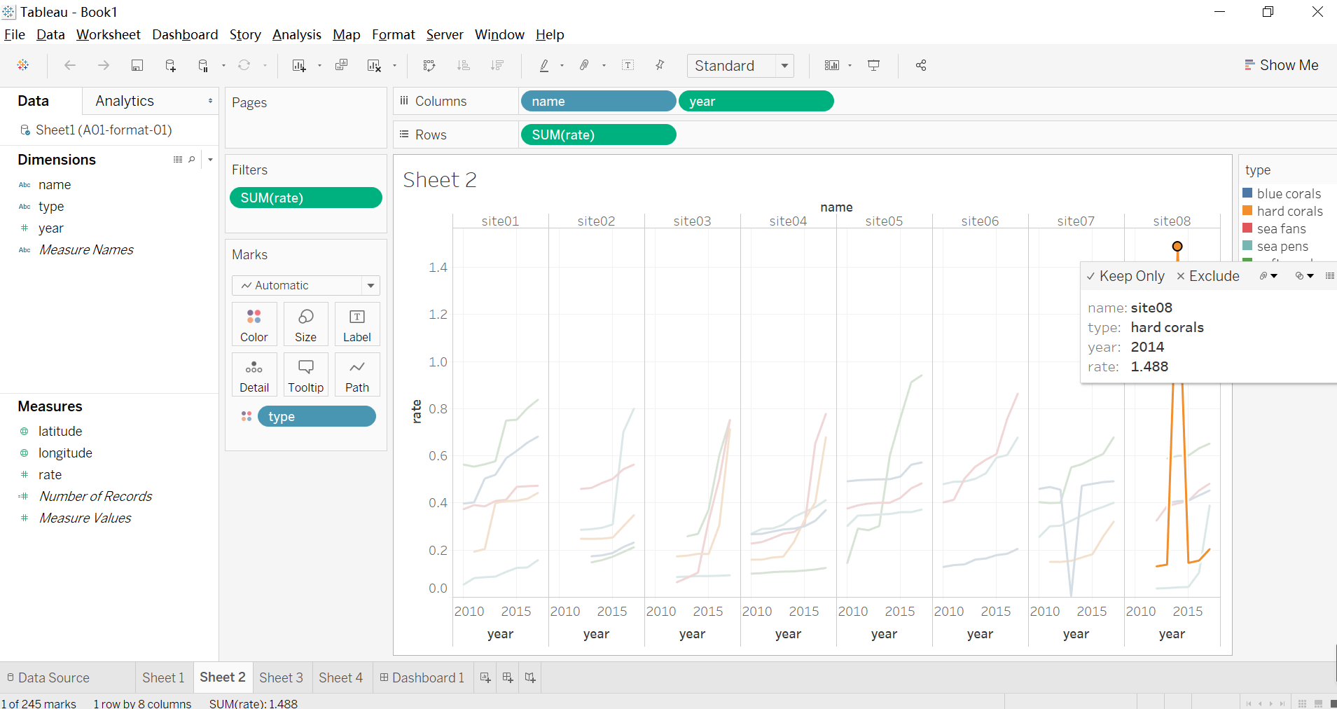

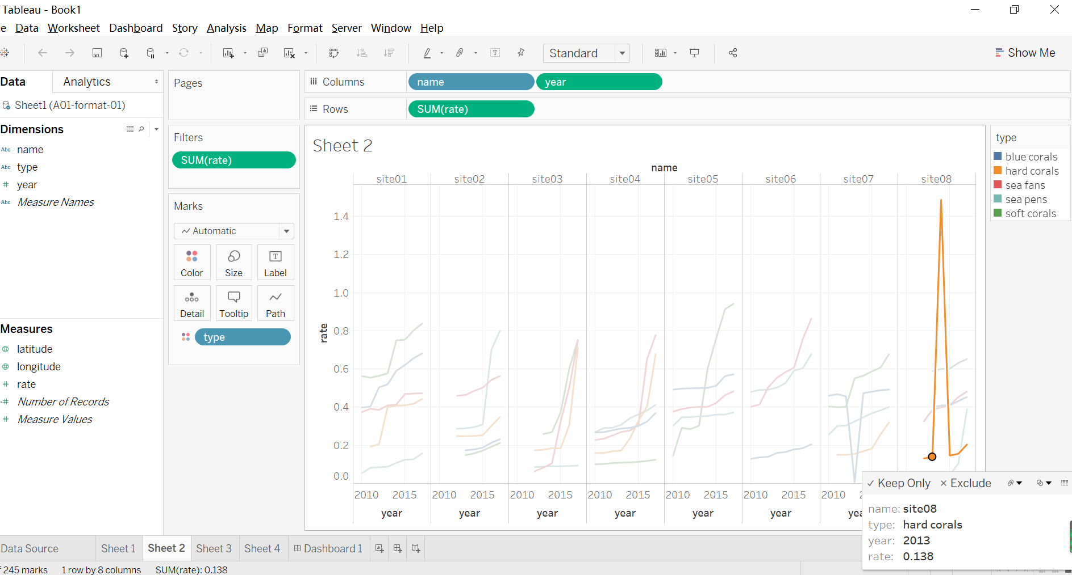

Similarly，blue corals’ rate in 2013 of site 07 decreased so quickly and return to normal rate next year. Comparing with the rate in other years, it also because of wrong decimal point. The rate in 2014 should be 0.4696 instead of 0.004696. The result that after correcting shows the growth curve can meet the normal trend now.

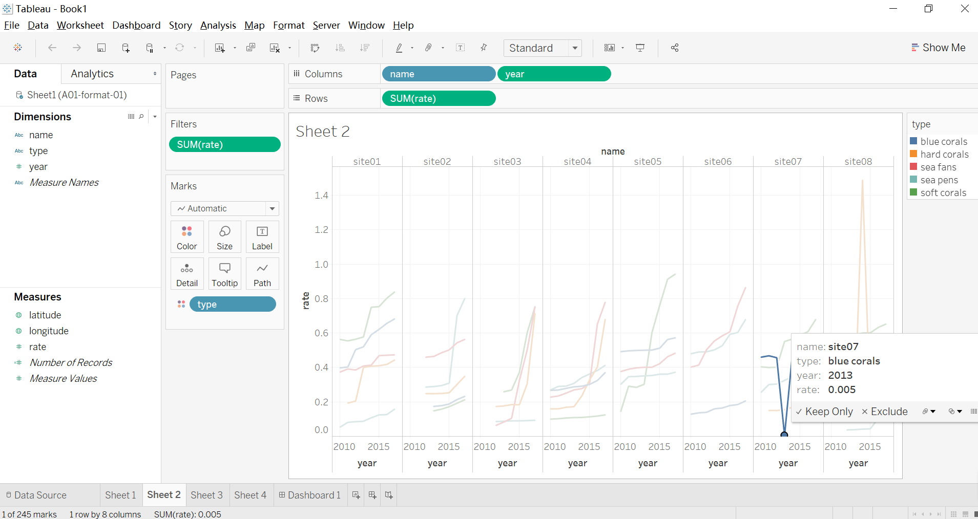

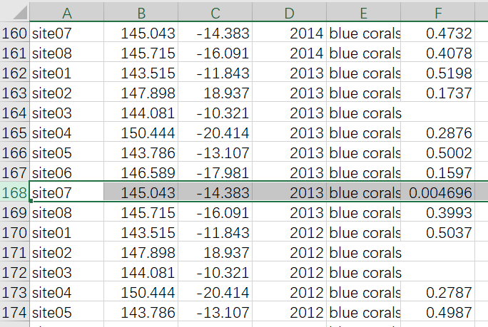

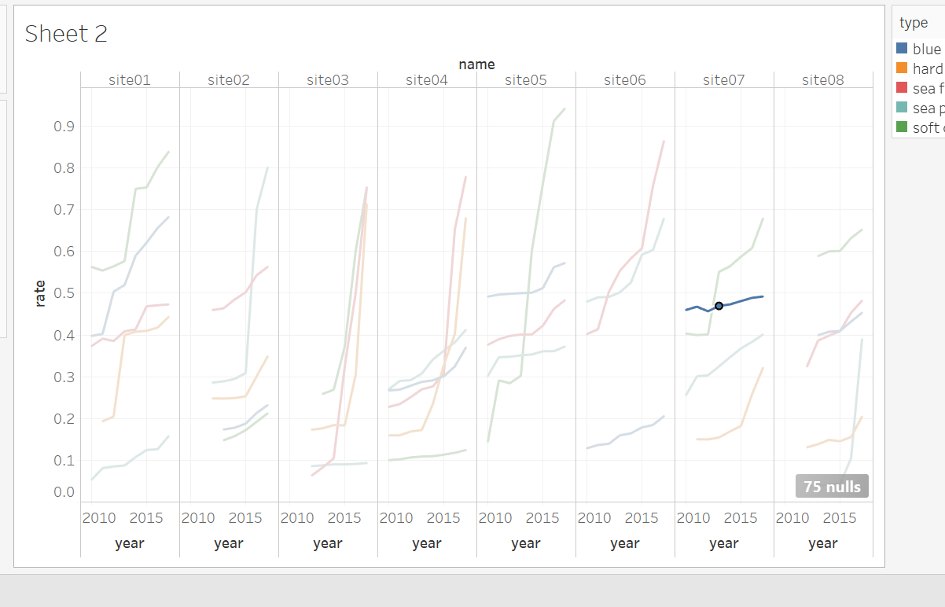

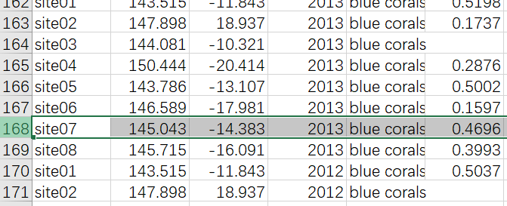

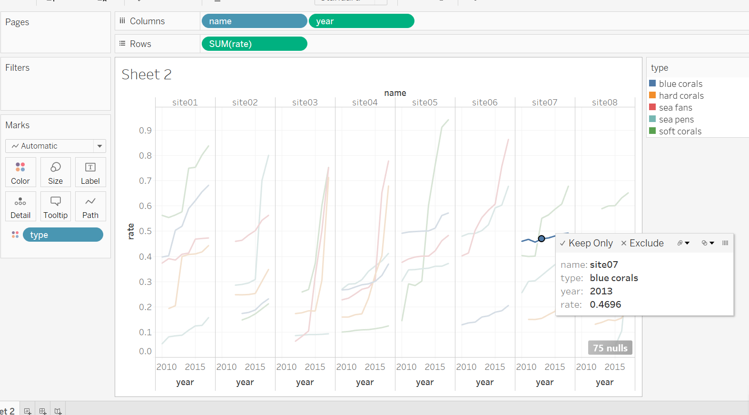

As for the location of site, the site 2 looks very far away from others, comparing with the other site, I think this site’s latitude should be -18.937. The map that after changing the latitude show all of sites locate belong the east coast of mainland.

